Title
“Judging books by their covers”
Central Focus | Illustration / book cover design
Grade Level | Middle School (7th grade)
Class Size | 20
Time | First Hour (8:00-8:45)
Class Demographics | White, Indian, and Black students.

Standards Addressed
Copy and paste the whole standard and code for the grade-specific standards this lesson will address.
Day 1:
- VA:Re7.2.7a - Analyze multiple ways that images influence specific audiences.

- VA:Cr1.2.7a - Develop criteria to guide making a work of art or design to meet an identified goal.
Day 2:
- VA:Pr4.1.7a - Compare and contrast how technologies have changed the way artwork is preserved, presented, and experienced.

- VA:Cr1.2.7a - Develop criteria to guide making a work of art or design to meet an identified goal.
Day 3:
- VA:Cr2.3.7a - Apply visual organizational strategies to design and produce a work of art, design, or media that clearly communicates information or ideas.

- VA:Re7.2.7a - Analyze multiple ways that images influence specific audiences.

UNIT OVERVIEW
Briefly describe in 2-3 succinct sentences what students will do during this unit and why you are teaching this material.
- Students will be learning about illustration and book cover design.
- Students will be learning about how the imagery on book covers can influence an audience.
- Students will find a book that they have read and create two alternative book covers for that book.
- Students will view each other’s book covers and determine what kind of affect it had on the audience.

Interdisciplinary Connections
- List at least 2 other disciplines, subjects or content areas this lesson connects to.
- Literature and math.
- Talking about book covers requires us to talk about the books behind them. Part of the assignment is to have read the book and critically think about how the book could be compressed or represented in a book cover. Reading comprehension is involved.
- Math will come into play when mapping out the book cover and making sure its proportionate.

UNIT LEARNING OBJECTIVES

As a result of this lesson, students will be able to:
- Objectives should each be one sentence that states in precise terms what knowledge or skill will be fostered in this lesson.
- Each objective should relate to a standard it addresses.
- Use active language describing observable and assessable behavior here.

Day 1:
VA:Re7.2.7a - Analyze multiple ways that images influence specific audiences.
- The student will be able to… list 5 ways images have the power to influence an audience (looking at themselves as the audience).
- The student will be able to… compare two different audiences and describe the differences in which the audience would react to a given image.

VA:Cr1.2.7a - Develop criteria to guide making a work of art or design to meet an identified goal.
- The student will be able to construct criteria/rubric that guides the creation of their book cover.

Day 2:
VA:Pr4.1.7a - Compare and contrast how technologies have changed the way artwork is preserved, presented, and experienced.
- The student will be able to…discuss how technology has changed the way art is created and experienced.
- The student will be able to… list the pros and cons of using technology vs physical art.

VA:Cr2.3.7a - Apply visual organizational strategies to design and produce a work of art, design, or media that clearly communicates information or ideas.
- The student will be able to… create 2 rough drafts of alternative book covers (that meet the criteria/rubrics that they created day 1).

Day 3:
VA:Cr2.3.7a - Apply visual organizational strategies to design and produce a work of art, design, or media that clearly communicates information or ideas.
- The student will be able to… create 2 final copies of alternative book covers (that meet the criteria/rubrics that they created day 1).
- The student will be able to… explain how their alternative book covers clearly communicate information/ideas.

VA:Re7.2.7a - Analyze multiple ways that images influence specific audiences.
- The student will be able to… assess whether their classmates alternative book covers had influence on specific audiences.

TEACHER MATERIALS
- One iPad with Procreate downloaded.
- One apple pencil.
- Optional guided notes sheet.
- Powerpoint.
- Example of the final project (done by teacher).
- Demo video – how to use procreate/how to create a file in the right scale.
- Notecards
- Worksheets for brainstorming and final reflections

STUDENT MATERIALS

Each student will need…
- One iPad and Procreate downloaded.
- One apple pencil.
- Paper or iPad for thumbnails.
- Computer for downloading and sharing thumbnails and book covers.

ARTISTS IN CONTEXT
Key Artists | List at least 6 diverse artists  - Kara Walker (https://art21.org/watch/art-in-the-twenty-first-century/s2/kara-walker-in-stories-segment/)  - Trenton Doyle Hancock (https://art21.org/read/trenton-doyle-hancock-storytelling-characters-and-colors/)  - Diana Al-Hadid (https://art21.org/watch/new-york-close-up/diana-al-hadid-plays-the-classics/)  - Kiki Smith (https://art21.org/watch/art-in-the-twenty-first-century/s2/kiki-smith-in-season-2-of-art-in-the-twenty-first-century-2003-preview/)  - Yun-Fei Ji (https://art21.org/watch/artist-to-artist/yun-fei-ji-with-kerry-james-marshall-at-prospect-3/)  - Carrie Mae Weems(https://art21.org/watch/art-in-the-twenty-first-century/s5/carrie-mae-weems-in-compassion-segment/)
Key Artworks | Artist, Artwork Title, Year (list at least 2)  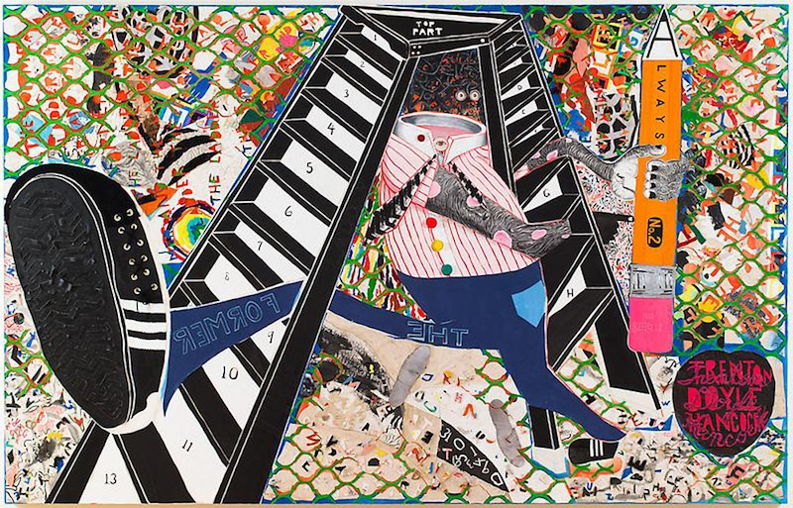  Trenton Doyle Hancock, The Former and the Ladder or Ascension and a Cinchin’, 2012.  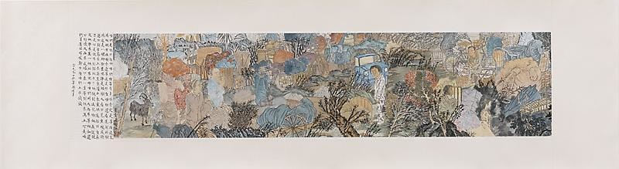  Yun-Fei Ji, The Meeting Point, 2009
Key Critical Questions | - List at least 4 critical questions about key artworks that ground writing and discussion activities  - What story do you think is being told when looking at The Former and the Ladder and The Meeting Point?  - If the artwork was a cover to a book, what do you think the book would be about?  - What are some of the formal elements? What effect to they have on you as the viewer?  - How do the titles of the artworks help you decipher the story being told?

VOCABULARY AND LANGUAGE ACQUISITION
Vocabulary | Include ALL words as well as definitions for all terms related to this lesson that you will emphasize. Remember to think about age-appropriate language when wording definitions.
Language Functions | analyze, compare/contrast, critique, describe, interpret, question, etc.
Language Demands | Syntax | Discourse
Language Tasks and Activities | - Describe 2 key language/vocab learning tasks students will do
Language Supports | - Describe 2 instructional support materials that will help students use the language functions and demands

SPECIAL PRE-INSTRUCTION PREPARATIONS
- What special preparations need to be made by the teacher before beginning this unit? Schedule a field trip? Schedule a guest speaker? Have students compile/collect special supplies? Have specific equipment on hand? Etc.

ACCOMODATIONS FOR SPECIFIC DIVERSE LEARNERS
Adaptations and Accommodations
List and describe at least 2 adaptations and accommodations you will perform to facilitate all students’ learning. Cite specific activities, teaching practices, tasks, materials etc. from your Set Induction, Instruction and Lesson Closure procedures above that you will adapt and be as detailed as possible about HOW you will accommodate students’ needs.
- I created a demo video and uploaded it to my Google Classroom for the students. This will help students that were unable to attend class and help those students that might have missed a step in my in-class demo.
- Instead of having big class discussion questions all week, I split up the discussions into small groups or partner discussions. This will allow all students to have a chance to get participation points.
Enrichment and Extensions
List and describe at least 1 activity you plan to engage advanced students in during and/or after
the lesson. Think beyond simply having advanced students “help other students” as this tends to be an unfair practice.
- I will challenge my more advanced students to create one book cover that represents the story and creates a strong audience reaction, and the other book cover to juxtapose what is in the book (but also produce a strong audience reaction).
- This activity makes the final project a little more interesting for those that can handle a little more of a challenge.
Activity for Early Finishers
List and describe at least 1 engaging and related activity you plan for early finishers to engage in.
- Early finishers will start to create images for the inside of the book. Even if that is just an image on the page that introduces a new chapter.

OBJECTIVE-DRIVEN ASSESSMENTS
- Describe the specific tools and methods you will use as formative and summative assessment of students’ mastery of the Lesson Objectives listed above. Correlate each assessment described with the specific objectives above the tool is designed to assess.
- 4th grade lesson example = Rubric assessing students’ finished project originality, conceptual development, craftsmanship, effort, and participation. (Objectives 1, 3, 4)
- I will have two rubrics that will help me to grade the two alternative book covers based on craftsmanship, originality, concept, completion, and formal qualities. (summative)
- I will be tallying the participation in the group discussions we have in class. (formative)
- I will grade based on completion for most formal assessments like compare and contrast exercises, bell work, thumbnails, etc.

REFERENCES
You must have references to books, web pages, films, etc. you used in the development and execution of your lesson, to allow you to teach the lesson again, or to allow someone else to teach the lesson. Use APA style in formatting the reference list.
Carrie Mae Weems in. Art21. (n.d.-a). https://art21.org/watch/art-in-the-twenty-first-century/s5/carrie-mae-weems-in-compassion-segment/
Diana al-Hadid plays the classics. Art21. (n.d.-a). https://art21.org/watch/new-york-close-up/diana-al-hadid-plays-the-classics/
Kara Walker in. Art21. (n.d.). https://art21.org/watch/art-in-the-twenty-first-century/s2/kara-walker-in-stories-segment/
Kiki Smith in. Art21. (n.d.-c). https://art21.org/watch/art-in-the-twenty-first-century/s2/kiki-smith-in-season-2-of-art-in-the-twenty-first-century-2003-preview/
Yun-Fei Ji with Kerry James Marshall at prospect.3. Art21. (n.d.-d). https://art21.org/watch/artist-to-artist/yun-fei-ji-with-kerry-james-marshall-at-prospect-3/

* Developed and written by Annie Dew, Art Education, Illinois State University, 2024 *

INSTRUCTIONAL STRATEGIES AND LEARNING TASKS DAY / LESSON 1
VA:Re7.2.7a - Analyze multiple ways that images influence specific audiences.
- VA:Re7.2.7a - Analyze multiple ways that images influence specific audiences.
VA:Re7.2.7a - Analyze multiple ways that images influence specific audiences.
- The student will be able to… list 5 ways images have the power to influence an audience (looking at themselves as the audience).
- The student will be able to… compare two different audiences and describe the differences in which the audience would react to a given image.
VA:Cr1.2.7a - Develop criteria to guide making a work of art or design to meet an identified goal.
- The student will be able to construct criteria/rubric that guides the creation of their book cover.

Launch (10 minutes) | Instruction Methods
- I will start my lesson by greeting students at the door and having them go to their seats.  - Once the bell rings I will go to the front of the room and ask students to think about their favorite illustrated book. (I want the students to begin thinking about illustration and recalling what they know about it.)  - We will share our favorite books and I will help lead the discussion.  - Questions:  - “what do you enjoy about this book?”  - “why do you like the visuals?”  - “how do the visuals connect to the text?”  - Do you think images/visuals have as much impact as text?” | - Group discussion.
Instruction (20 minutes) | Instruction Methods
- The last question from the launch will transition us into the instruction.  - I will put my PowerPoint on the smartboard.  - I will begin by introducing the key artists, Trenton Doyle Hancock and Yun-Fei Ji. (switch the slides accordingly)  - Both artists focus on storytelling, and we are going to see whether we (the audience) can understand the story they are telling.  - Questions: (also listed above).  - What story do you think is being told when looking at The Former and the Ladder and The Meeting Point?  - If the artwork was a cover to a book, what do you think the book would be about?  - What are some of the formal elements? What effect to they have on you as the viewer?  - How do the titles of the artworks help you decipher the story being told?  - When the discussion has come to an end, the teacher will start talking about the connection between the artists we talked about and book cover design/ storytelling.  - The teacher will explain how people design book covers and we will talk about different kinds of book covers.  - The teacher will connect to the launch section of the lesson by talking about art vs art in books.  - I will ask the students a few questions to wrap up the instruction section:  - “do you typically think about book covers in the same way you think about art like Trenton Doyle Hancock or Yun-Fei Ji?”  - “are there any book covers you know of that could have more of an impact on the audience?”  - “how would you redesign a book cover to have a bigger effect on the audience?”  - After the students answer this question, I will introduce the final project, which is choosing a book cover – making 2 re-designs of the book cover that create more of an impact for the viewer.  - The teacher will begin the closure. | - Group discussion.  - Teacher lecture.
Closure (15 minutes) | Instruction Methods
- I will pass out a brainstorming handout for the project.  - The brainstorming worksheet is homework.  - There will be questions like this:  - “list 3 book covers you would consider redesigning”.  - “write criteria for your book cover – how do you want the audience to feel when they look at it ?” (think about formal elements, craftsmanship, and completion)  - I will give the students some time in class to start this, but it will be homework that is due at the start of the next class time. | - Independent student work.

INSTRUCTIONAL STRATEGIES AND LEARNING TASKS DAY / LESSON 2
VA:Pr4.1.7a - Compare and contrast how technologies have changed the way artwork is preserved, presented, and experienced.
- The student will be able to…discuss how technology has changed the way art is created and experienced.
- The student will be able to… list the pros and cons of using technology vs physical art.

VA:Cr2.3.7a - Apply visual organizational strategies to design and produce a work of art, design, or media that clearly communicates information or ideas.
- The student will be able to… create 2 rough drafts of alternative book covers (that meet the criteria/rubrics that they created day 1).

Launch | Instruction Methods
- I will start my lesson by greeting students at the door and having them go to their seats.  - When the bell rings, I will go to the front of the classroom and ask students how they are doing.  - Once we do the emotional check in, I will ask, “what did we talk about yesterday?”  - Students will recall information from the day before.  - We will talk briefly about the key artists and the connection between art and storytelling.  - Then we will begin talking about the homework, the brainstorming worksheet.  - I will instruct the students to get out worksheet, and I will be walking around the class, marking who completed it and who did not. (I will give completion points for this formative assessment)  - Once I have checked the homework, I will start the lecture. | - Class discussion
Instruction | Instruction Methods
- I will start by pulling up my PowerPoint presentation.  - Then I will ask the students some questions:  - “what are some positives about technology/what do you like about technology?”  - “what are some negatives about technology/what do you not like about technology?”  - “how is technology used to make art?”  - Now I will do an introduction to technology and art.  - I will explain all the ways that people can make art using technology. Showing them some examples as I go.  - I will also ask the students if there is other technology that I might have missed.  - I will then introduce Procreate.  - We will be using the iPads in the classroom, and the app Procreate to complete our alternative book covers.  - Today we are focusing on learning how to use the app.  - At this time, I will have all my students get an iPad from the front of the room.  - I will lead a “follow along” demo of the app procreate.  - I will also have a demo video uploaded on the classes Google Classroom.  - I will then have everyone pause and turn off their iPads for a minute, while I describe their assignment.  - The rest of the class the students will have time to create 2 rough drafts of the alternative book covers using Procreate. They will use their brainstorming sheet to decide which book cover they are editing.  - With about 10 minutes left in class, I will have my students pick up and put their iPads away. | - Big class/small group discussion  - Independent work
Closure | Instruction Methods
- When students put their iPad, they will each pick up one notecard.  - They will answer the exit slip question with their notecard.  - I will have the exit slip question on the board and I will also say it out loud.  - “list 5 pros and 5 cons of using technology to make art.”  - Using one notecard, I will have students write the pros and cons of using technology to make art.  - They will turn this in as they walk out of the classroom, and they will get completion points for doing so. (formative assessment) | - Independent work

INSTRUCTIONAL STRATEGIES AND LEARNING TASKS DAY / LESSON 3
VA:Cr2.3.7a - Apply visual organizational strategies to design and produce a work of art, design, or media that clearly communicates information or ideas.
- The student will be able to… create 2 final copies of alternative book covers (that meet the criteria/rubrics that they created day 1).
- The student will be able to… explain how their alternative book covers clearly communicate information/ideas.

VA:Re7.2.7a - Analyze multiple ways that images influence specific audiences.
- The student will be able to… assess whether their classmates alternative book covers had influence on specific audiences.

Launch | Instruction Methods
- I will start my lesson by greeting students at the door and having them go to their seats.  - When the bell rings, I will go to the front of the classroom and ask students how they are doing.  - Once we do the emotional check in, I will ask them to turn and talk to their neighbor about what we did in class yesterday. (recalling information from the day before) | - Turn and talk, discussion with a partner
Instruction | Instruction Methods
- We will jump right into instruction for the day.  - I will give instructions for the day.  - “Today is primarily a workday! You will be creating your 2 final copies of alternative book covers. Remember to connect them to the criteria you set for yourself on day one! Then we are going to get a partner and you are going to discuss what you created. You will get a worksheet that will help lead the discussion about you and your partners artwork.”  - The worksheet will include these questions:  - “how does your alternative book covers communicate information/represent the book?”  - “how do you feel when you look at your partners book cover?” (remember no wrong answers here, do your best!)  - While the students are having their partner discussions, I will walk around, making sure they stay on track and contributing to their discussions about their work.  - Once we are nearing the end of class, we will come together as a big group, for one last group discussion about this unit. | - Individual worktime  - Discussion with a partner
Closure | Instruction Methods
- We will wrap up this class by recalling what we have learned.  - I will ask the class what they learned from this unit.  - I will also ask them to share about their experiences using Procreate and trying to add more meaning to a book cover.  - Before the students leave, I will have them upload the two files with their alternative book covers to an assignment in Google Classroom.  - Then they will turn in the worksheets they filled out during class.  - They will turn in the iPads.  - Then they will leave. | - Big class discission.

